|  |
| --- |
| **VISVESVARAYA TECHNOLOGICAL UNIVERSITY**  **“JnanaSangama”, Belgaum -590014, Karnataka.**    **LAB RECORD**  **Bio Inspired Systems (23CS5BSBIS)**  ***Submitted by***  **Dhruv Rampuria(1BM22CS088)**  ***in partial fulfillment for the award of the degree of***  **BACHELOR OF ENGINEERING**  ***in***  **COMPUTER SCIENCE AND ENGINEERING**    **B.M.S. COLLEGE OF ENGINEERING**  **(Autonomous Institution under VTU)**  **BENGALURU-560019**  **Sep-2024 to Jan-2025** |

**B.M.S. College of Engineering,**

**Bull Temple Road, Bangalore 560019**

(Affiliated To Visvesvaraya Technological University, Belgaum)

**Department of Computer Science and Engineering**



**CERTIFICATE**

This is to certify that the Lab work entitled “ Bio Inspired Systems (23CS5BSBIS)” carried out by **Dhruv Rampuria(1BM22CS088),** who is bonafide student of **B.M.S. College of Engineering.** It is in partial fulfillment for the award of **Bachelor of Engineering in Computer Science and Engineering** of the Visvesvaraya Technological University, Belgaum. The Lab report has been approved as it satisfies the academic requirements of the above mentioned subject and the work prescribed for the said degree.

|  |  |
| --- | --- |
| Leelavathi B  Assistant Professor  Department of CSE, BMSCE | Dr. Kavitha Sooda  Professor & HOD  Department of CSE, BMSCE |

**Index**

|  |  |  |  |
| --- | --- | --- | --- |
| **Sl.**  **No.** | **Date** | **Experiment Title** | **Page No.** |
| 1 | 3/10/24 | Genetic Algorithm | 1-6 |
| 2 | 24/10/24 | Particle Swarm Optimization | 7-9 |
| 3 | 7/11/24 | Ant Colony Optimization | 10-14 |
| 4 | 14/11/24 | Cuckoo Search | 15-18 |
| 5 | 21/11/24 | Grey Wolf Optimization | 19-22 |
| 6 | 28/11/24 | Parallel Cellular Algorithm | 23-24 |
| 7 | 5/12/24 | Optimization Via Gene Expression Algorithm | 25-29 |

Github Link:

[DhruvR-2004/BIS_LAB](https://github.com/DhruvR-2004/BIS_LAB)

**Program 1**

**Genetic Algorithm for Optimization Problems.**

Implement a Genetic Algorithm using Python to solve a basic optimization problem, such as finding the maximum value of a mathematical function.

Algorithm:

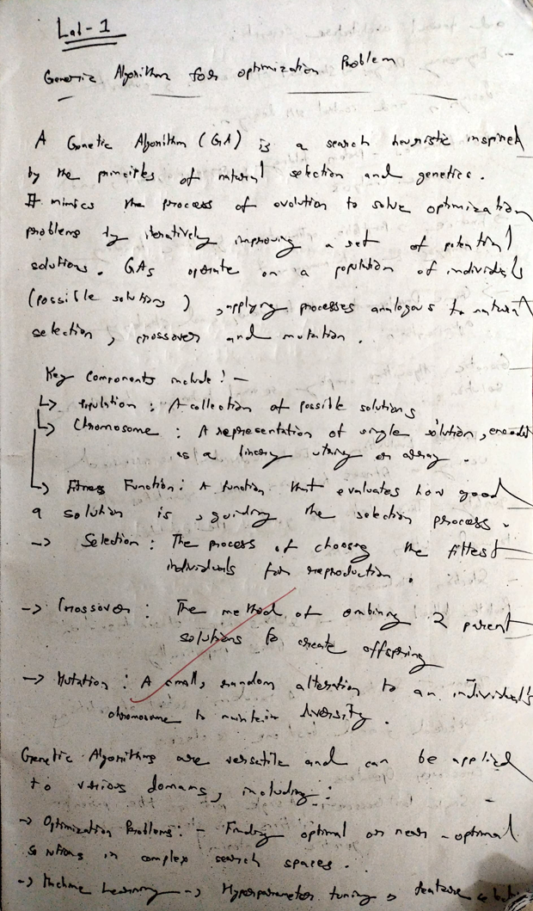

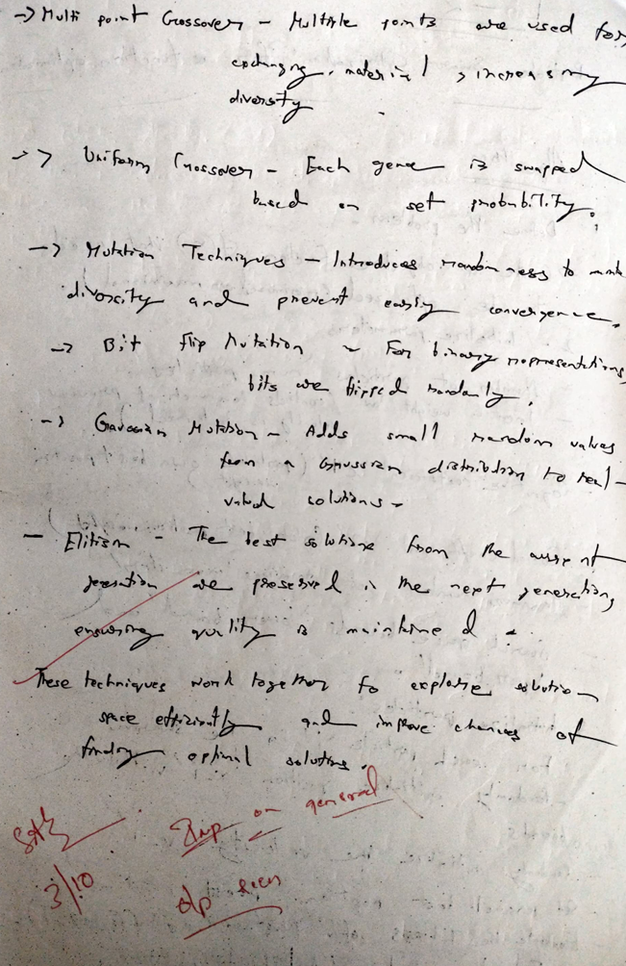

Code:

import numpy as np

import random

POPULATION_SIZE = 10

GENES = 8

GENERATIONS = 50

MUTATION_RATE = 0.1

def fitness_function(x):

return x**2

def decode_chromosome(chromosome):

return int("".join(map(str, chromosome)), 2)

def initialize_population():

return [np.random.randint(0, 2, GENES).tolist() for _ in range(POPULATION_SIZE)]

def evaluate_fitness(population):

return [fitness_function(decode_chromosome(individual)) for individual in population]

def select_parents(population, fitness):

total_fitness = sum(fitness)

probabilities = [f / total_fitness for f in fitness]

selected = random.choices(population, weights=probabilities, k=2)

return selected

def crossover(parent1, parent2):

point = random.randint(1, GENES - 1)

offspring1 = parent1[:point] + parent2[point:]

offspring2 = parent2[:point] + parent1[point:]

return offspring1, offspring2

def mutate(individual):

for i in range(len(individual)):

if random.random() < MUTATION_RATE:

individual[i] = 1 - individual[i] # Flip the bit

return individual

def genetic_algorithm():

# Step 1: Initialize population

population = initialize_population()

for generation in range(GENERATIONS):

# Step 2: Evaluate fitness

fitness = evaluate_fitness(population)

# Logging the best solution of the generation

best_individual = population[np.argmax(fitness)]

best_fitness = max(fitness)

print(f"Generation {generation + 1}: Best Fitness = {best_fitness}")

# Step 3: Create the next generation

new_population = []

while len(new_population) < POPULATION_SIZE:

# Step 4: Select parents

parent1, parent2 = select_parents(population, fitness)

# Step 5: Crossover

offspring1, offspring2 = crossover(parent1, parent2)

# Step 6: Mutate

new_population.append(mutate(offspring1))

if len(new_population) < POPULATION_SIZE:

new_population.append(mutate(offspring2))

population = new_population

fitness = evaluate_fitness(population)

best_individual = population[np.argmax(fitness)]

best_fitness = max(fitness)

best_solution = decode_chromosome(best_individual)

print("\nFinal Best Solution:")

print(f"Chromosome: {best_individual}, Decoded: {best_solution}, Fitness: {best_fitness}")

if __name__ == "__main__":

genetic_algorithm()

**Program 2**

**Particle Swarm Optimization for Function Optimization.**

Implement the PSO algorithm using Python to optimize a mathematical function.

Algorithm:

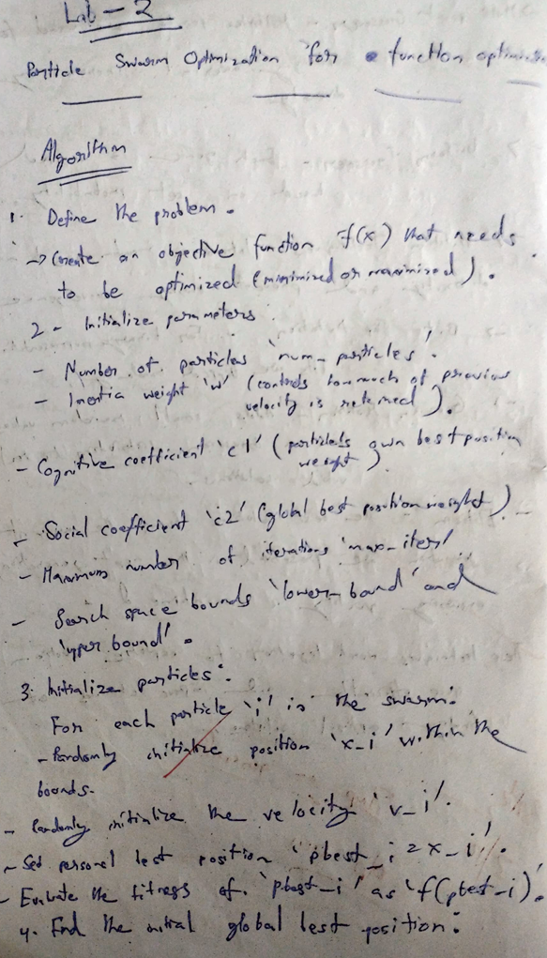

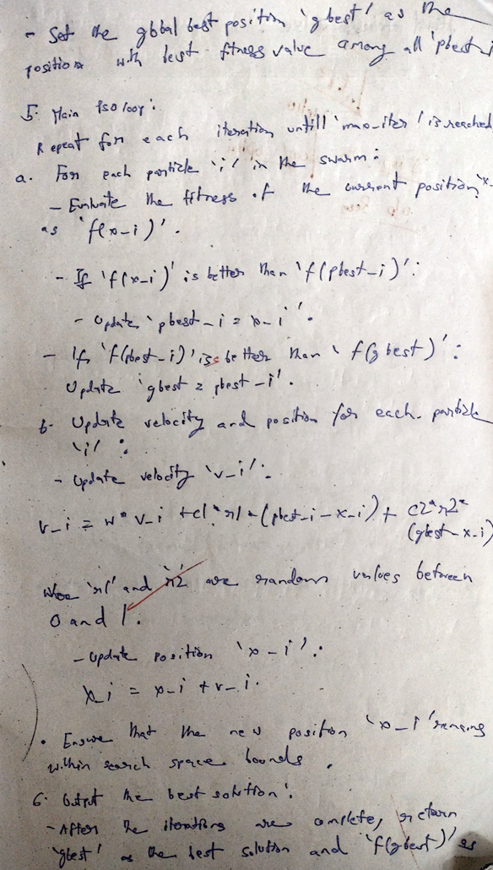

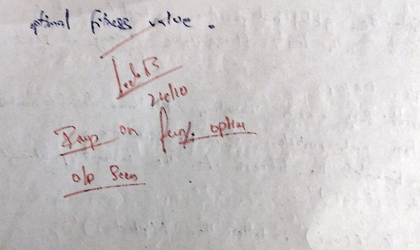

Code:

import random

import numpy as np

class Particle:

def __init__(self, dim, bounds):

self.position = np.array([random.uniform(bounds[0], bounds[1]) for _ in range(dim)])

self.velocity = np.array([random.uniform(-1, 1) for _ in range(dim)])

self.best_position = self.position.copy()

self.best_score = float('inf')

def update_velocity(self, global_best_position, w, c1, c2):

inertia = w * self.velocity

cognitive = c1 * random.random() * (self.best_position - self.position)

social = c2 * random.random() * (global_best_position - self.position)

self.velocity = inertia + cognitive + social

def update_position(self, bounds):

self.position = self.position + self.velocity

self.position = np.clip(self.position, bounds[0], bounds[1])

def evaluate(self, objective_function):

score = objective_function(self.position)

if score < self.best_score:

self.best_score = score

self.best_position = self.position.copy()

class PSO:

def __init__(self, objective_function, dim, bounds, num_particles, max_iter, w=0.5, c1=1.5, c2=1.5):

self.objective_function = objective_function

self.dim = dim

self.bounds = bounds

self.num_particles = num_particles

self.max_iter = max_iter

self.w = w

self.c1 = c1

self.c2 = c2

self.global_best_position = None

self.global_best_score = float('inf')

self.particles = [Particle(dim, bounds) for _ in range(num_particles)]

def optimize(self):

for iteration in range(self.max_iter):

for particle in self.particles:

particle.evaluate(self.objective_function)

if particle.best_score < self.global_best_score:

self.global_best_score = particle.best_score

self.global_best_position = particle.best_position.copy()

for particle in self.particles:

particle.update_velocity(self.global_best_position, self.w, self.c1, self.c2)

particle.update_position(self.bounds)

print(f"Iteration {iteration+1}/{self.max_iter}, Best Score: {self.global_best_score}")

return self.global_best_position, self.global_best_score

def objective_function(x):

return sum(xi**2 for xi in x)

dim = 2

bounds = (-10, 10)

num_particles = 30

max_iter = 100

pso = PSO(objective_function, dim, bounds, num_particles, max_iter)

best_position, best_score = pso.optimize()

print("Optimal Solution: ", best_position)

print("Best Score: ", best_score)

**Program 3**

**Ant Colony Optimization for the Traveling Salesman Problem**

Implement the ACO algorithm using Python to solve the TSP, where the objective is to find the shortest possible route that visits a list of cities and returns to the origin city.

Algorithm:

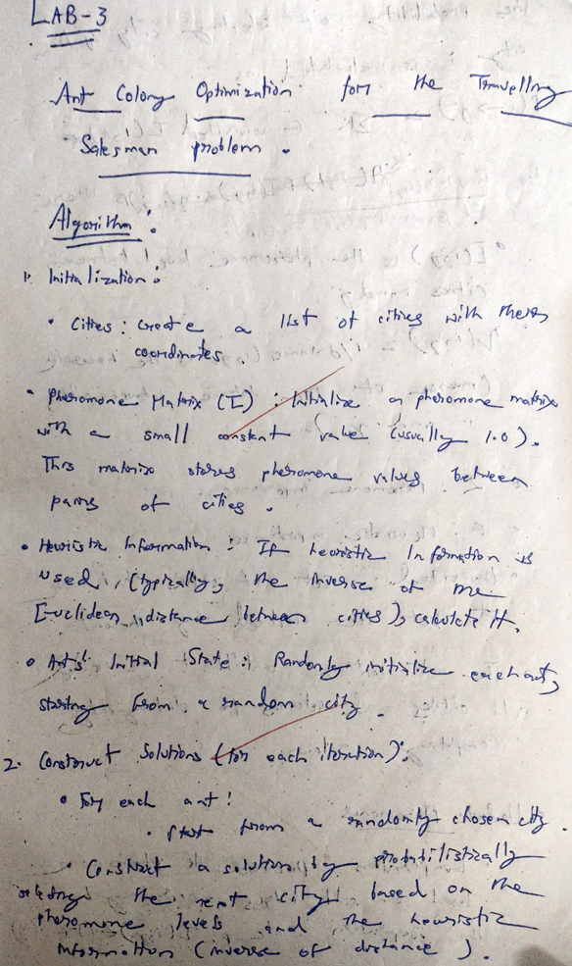

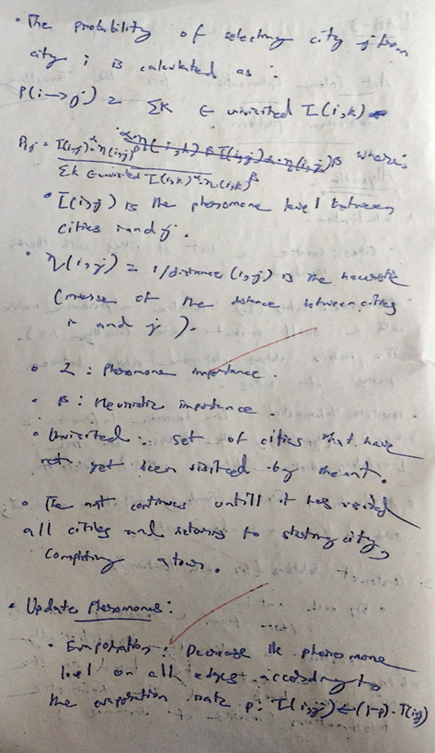

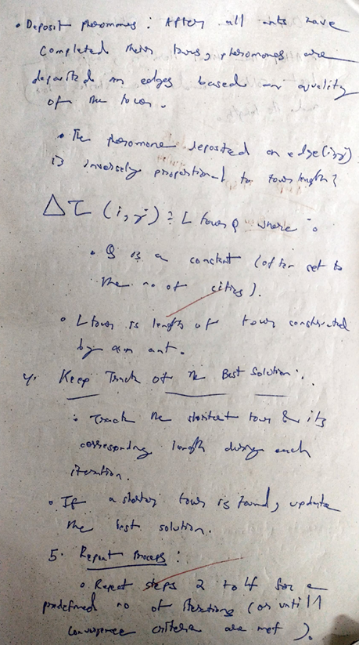

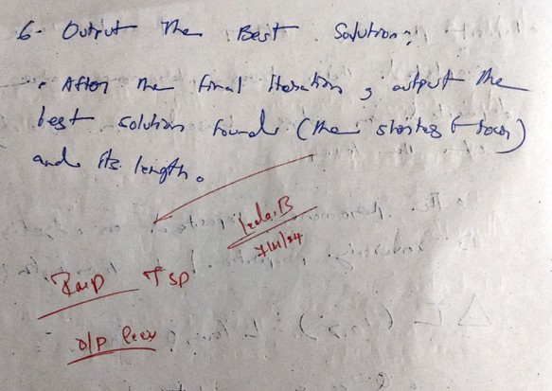

Code:

import random

import numpy as np

class AntColony:

def __init__(self, dist_matrix, num_ants, num_iterations, alpha=1, beta=2, rho=0.1, q=100):

self.dist_matrix = dist_matrix

self.num_ants = num_ants

self.num_iterations = num_iterations

self.alpha = alpha

self.beta = beta

self.rho = rho

self.q = q

self.num_cities = len(dist_matrix)

self.pheromone_matrix = np.ones((self.num_cities, self.num_cities))

np.fill_diagonal(self.pheromone_matrix, 0)

def select_next_city(self, current_city, visited_cities):

probabilities = []

for city in range(self.num_cities):

if city not in visited_cities:

pheromone = self.pheromone_matrix[current_city][city] ** self.alpha

distance = self.dist_matrix[current_city][city] ** self.beta

probabilities.append(pheromone * distance)

else:

probabilities.append(0)

total_prob = sum(probabilities)

probabilities = [p / total_prob for p in probabilities]

return np.random.choice(range(self.num_cities), p=probabilities)

def construct_solution(self):

visited_cities = [random.randint(0, self.num_cities - 1)]

while len(visited_cities) < self.num_cities:

current_city = visited_cities[-1]

next_city = self.select_next_city(current_city, visited_cities)

visited_cities.append(next_city)

visited_cities.append(visited_cities[0])

return visited_cities

def calculate_solution_length(self, solution):

length = 0

for i in range(len(solution) - 1):

length += self.dist_matrix[solution[i]][solution[i + 1]]

return length

def update_pheromones(self, solutions, lengths):

self.pheromone_matrix *= (1 - self.rho)

for solution, length in zip(solutions, lengths):

for i in range(len(solution) - 1):

self.pheromone_matrix[solution[i]][solution[i + 1]] += self.q / length

def optimize(self):

best_solution = None

best_length = float('inf')

for _ in range(self.num_iterations):

solutions = []

lengths = []

for _ in range(self.num_ants):

solution = self.construct_solution()

length = self.calculate_solution_length(solution)

solutions.append(solution)

lengths.append(length)

if length < best_length:

best_solution = solution

best_length = length

self.update_pheromones(solutions, lengths)

print(f"Best Length in Iteration: {best_length}")

return best_solution, best_length

def generate_distance_matrix(num_cities):

matrix = np.random.randint(10, 100, size=(num_cities, num_cities))

np.fill_diagonal(matrix, 0)

return matrix

num_cities = 10

num_ants = 20

num_iterations = 100

dist_matrix = generate_distance_matrix(num_cities)

aco = AntColony(dist_matrix, num_ants, num_iterations)

best_solution, best_length = aco.optimize()

print("Best Solution (City Order):", best_solution)

print("Best Solution Length:", best_length)

**Program 4**

**Cuckoo Search (CS)**

Algorithm:

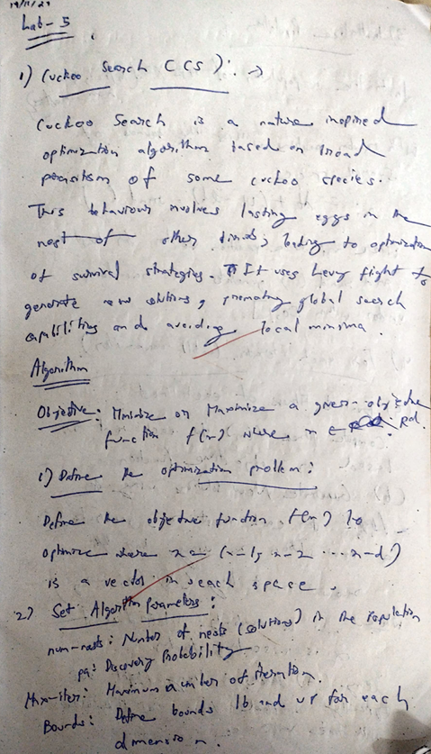

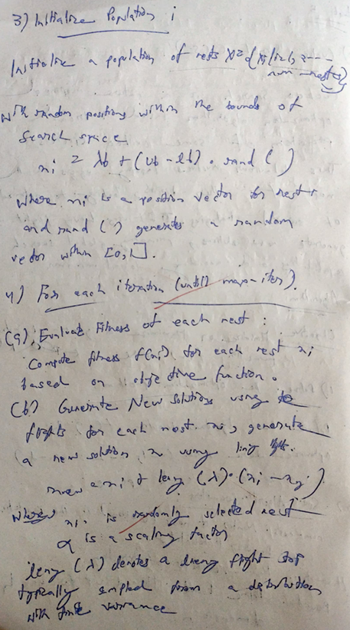

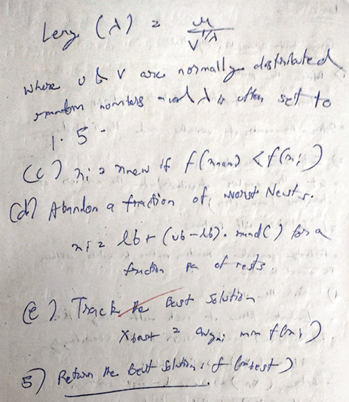

Code:

import numpy as np

import random

from scipy.special import gamma

def energy_function(x, y, theta):

A = 1.5

S = 1000

optimal_distance = 0.0

distance = np.sqrt(x**2 + y**2)

energy = (A * S) / (1 + distance) * np.cos(np.radians(theta))

return max(energy, 0)

class CuckooSearch:

def __init__(self, fitness_function, lower_bound, upper_bound, population_size=25, max_iter=100, pa=0.25):

self.fitness_function = fitness_function

self.lower_bound = np.array(lower_bound)

self.upper_bound = np.array(upper_bound)

self.population_size = population_size

self.max_iter = max_iter

self.pa = pa

self.n_dim = len(lower_bound)

self.population = np.random.uniform(self.lower_bound, self.upper_bound, (self.population_size, self.n_dim))

self.fitness = np.zeros(self.population_size)

self.best_solution = None

self.best_fitness = float('-inf')

def levy_flight(self, x):

beta = 1.5

sigma = (gamma(1 + beta) * np.sin(np.pi * beta / 2) / (gamma((1 + beta) / 2) * beta * 2**((beta - 1) / 2)))**(1 / beta)

u = np.random.normal(0, sigma, size=self.n_dim)

v = np.random.normal(0, 1, size=self.n_dim)

step = u / np.abs(v)**(1 / beta)

new_solution = x + step * 0.01

return np.clip(new_solution, self.lower_bound, self.upper_bound)

def cuckoo_search(self):

for iteration in range(self.max_iter):

for i in range(self.population_size):

new_solution = self.levy_flight(self.population[i])

new_fitness = self.fitness_function(*new_solution)

if new_fitness > self.fitness[i]:

self.population[i] = new_solution

self.fitness[i] = new_fitness

if new_fitness > self.best_fitness:

self.best_solution = new_solution

self.best_fitness = new_fitness

for i in range(self.population_size):

if random.random() < self.pa:

self.population[i] = np.random.uniform(self.lower_bound, self.upper_bound, self.n_dim)

self.fitness[i] = self.fitness_function(*self.population[i])

print(f"Iteration {iteration+1}/{self.max_iter}, Best Fitness (Energy): {self.best_fitness}")

return self.best_solution, self.best_fitness

lower_bound = [-10, -10, 0]

upper_bound = [10, 10, 90]

population_size = 25

max_iter = 100

pa = 0.25

cuckoo_search = CuckooSearch(energy_function, lower_bound, upper_bound, population_size, max_iter, pa)

best_solution, best_fitness = cuckoo_search.cuckoo_search()

print("Optimal Solar Panel Position and Tilt Angle:")

print(f"Position (x, y): {best_solution[:2]}, Tilt Angle (theta): {best_solution[2]} degrees")

print(f"Optimal Energy (Fitness): {best_fitness} Watts")

**Program 5**

**Grey Wolf Optimizer (GWO):**

Algorithm:

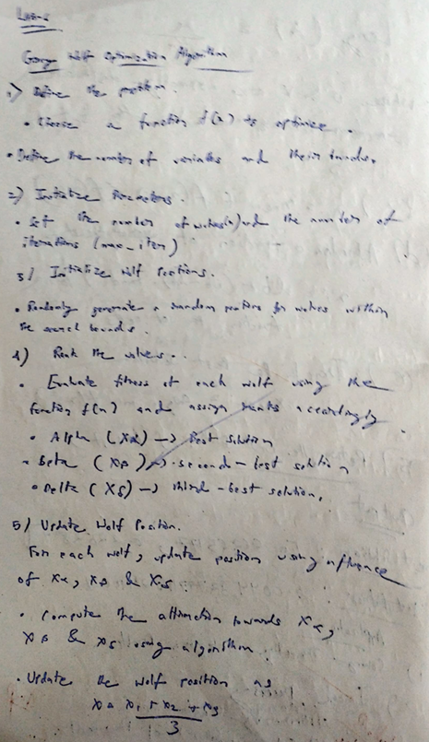

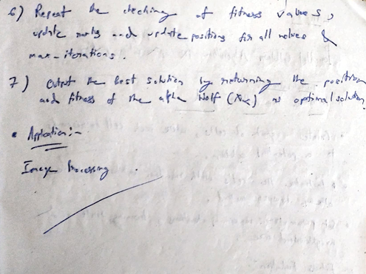

Code:

import numpy as np

def objective_function(x):

return np.sum(x**2)

def grey_wolf_optimizer(obj_func, dim, bounds, max_iter, pack_size):

alpha_pos = np.zeros(dim)

beta_pos = np.zeros(dim)

delta_pos = np.zeros(dim)

alpha_score = float("inf")

beta_score = float("inf")

delta_score = float("inf")

wolves = np.random.uniform(bounds[0], bounds[1], (pack_size, dim))

for t in range(max_iter):

for i in range(pack_size):

fitness = obj_func(wolves[i])

if fitness < alpha_score:

delta_score = beta_score

delta_pos = beta_pos.copy()

beta_score = alpha_score

beta_pos = alpha_pos.copy()

alpha_score = fitness

alpha_pos = wolves[i].copy()

elif fitness < beta_score:

delta_score = beta_score

delta_pos = beta_pos.copy()

beta_score = fitness

beta_pos = wolves[i].copy()

elif fitness < delta_score:

delta_score = fitness

delta_pos = wolves[i].copy()

a = 2 - t * (2 / max_iter)

for i in range(pack_size):

for j in range(dim):

r1, r2 = np.random.rand(), np.random.rand()

A1 = 2 * a * r1 - a

C1 = 2 * r2

D_alpha = abs(C1 * alpha_pos[j] - wolves[i, j])

X1 = alpha_pos[j] - A1 * D_alpha

r1, r2 = np.random.rand(), np.random.rand()

A2 = 2 * a * r1 - a

C2 = 2 * r2

D_beta = abs(C2 * beta_pos[j] - wolves[i, j])

X2 = beta_pos[j] - A2 * D_beta

r1, r2 = np.random.rand(), np.random.rand()

A3 = 2 * a * r1 - a

C3 = 2 * r2

D_delta = abs(C3 * delta_pos[j] - wolves[i, j])

X3 = delta_pos[j] - A3 * D_delta

wolves[i, j] = (X1 + X2 + X3) / 3

wolves[i] = np.clip(wolves[i], bounds[0], bounds[1])

return alpha_pos, alpha_score

dim = 5

bounds = (-10, 10)

max_iter = 100

pack_size = 20

best_position, best_score = grey_wolf_optimizer(objective_function, dim, bounds, max_iter, pack_size)

print("Best Position:", best_position)

print("Best Score:", best_score)

**Program 6**

**Parallel Cellular Algorithms and Programs:**

Algorithm:

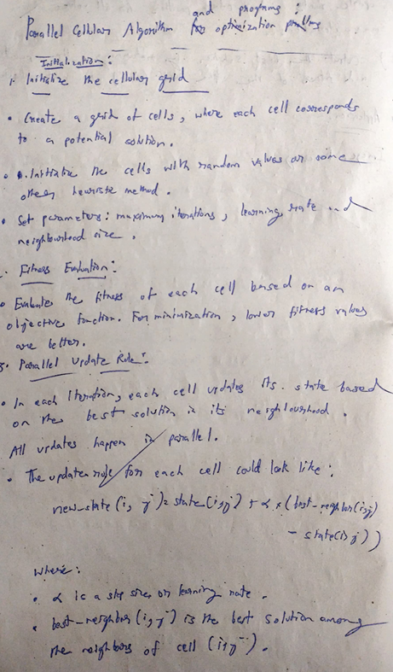

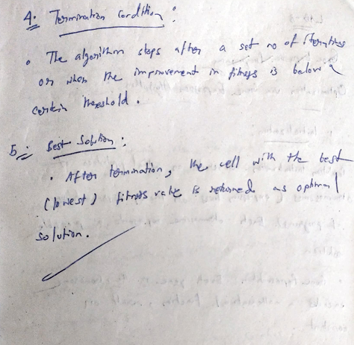

Code:

import numpy as np

def rastrigin_function(x, y):

return 10 * 2 + (x**2 - 10 * np.cos(2 * np.pi * x)) + (y**2 - 10 * np.cos(2 * np.pi * y))

def initialize_grid(grid_size, bounds):

return np.random.uniform(bounds[0], bounds[1], (grid_size, grid_size, 2))

def evaluate_grid(grid, fitness_function):

fitness_grid = np.zeros((grid.shape[0], grid.shape[1]))

for i in range(grid.shape[0]):

for j in range(grid.shape[1]):

x, y = grid[i, j]

fitness_grid[i, j] = fitness_function(x, y)

return fitness_grid

def get_neighbors(grid, i, j):

neighbors = [

grid[(i - 1) % grid.shape[0], j],

grid[(i + 1) % grid.shape[0], j],

grid[i, (j - 1) % grid.shape[1]],

grid[i, (j + 1) % grid.shape[1]],

]

return neighbors

def update_grid(grid, fitness_grid, bounds):

new_grid = grid.copy()

for i in range(grid.shape[0]):

for j in range(grid.shape[1]):

neighbors = get_neighbors(grid, i, j)

best_neighbor = min(neighbors, key=lambda n: rastrigin_function(n[0], n[1]))

if rastrigin_function(best_neighbor[0], best_neighbor[1]) < fitness_grid[i, j]:

new_grid[i, j] = best_neighbor + np.random.uniform(-0.1, 0.1, size=2)

new_grid[i, j] = np.clip(new_grid[i, j], bounds[0], bounds[1])

return new_grid

def parallel_cellular_algorithm(fitness_function, grid_size, bounds, max_iter):

grid = initialize_grid(grid_size, bounds)

for _ in range(max_iter):

fitness_grid = evaluate_grid(grid, fitness_function)

grid = update_grid(grid, fitness_grid, bounds)

best_cell = min(grid.reshape(-1, 2), key=lambda c: fitness_function(c[0], c[1]))

best_fitness = fitness_function(best_cell[0], best_cell[1])

return best_cell, best_fitness

grid_size = 10

bounds = (-5.12, 5.12)

max_iter = 100

best_solution, best_fitness = parallel_cellular_algorithm(rastrigin_function, grid_size, bounds, max_iter)

print("Best Solution:", best_solution)

print("Best Fitness:", best_fitness)

**Program 7**

**Optimization via Gene Expression Algorithms:**

Algorithm:

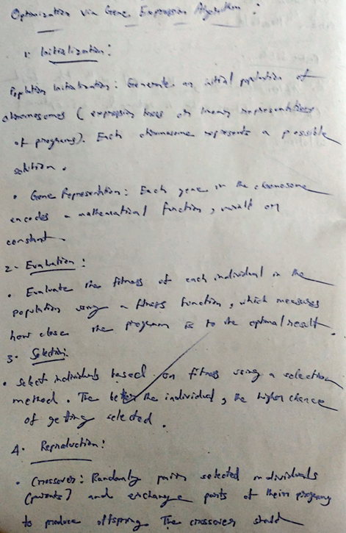

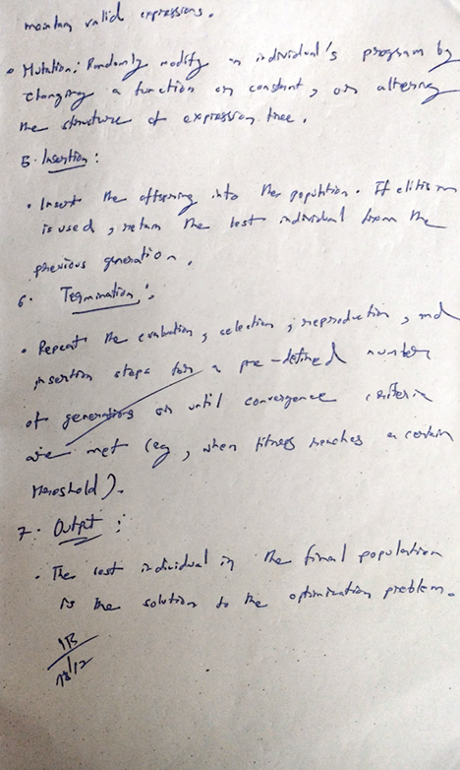

Code:

import numpy as np

def sphere_function(x):

return np.sum(x**2)

def initialize_population(pop_size, gene_length, bounds):

return np.random.uniform(bounds[0], bounds[1], (pop_size, gene_length))

def evaluate_fitness(population, fitness_function):

return np.array([fitness_function(individual) for individual in population])

def select_parents(population, fitness, num_parents):

sorted_indices = np.argsort(fitness)

return population[sorted_indices[:num_parents]]

def crossover(parents, offspring_size):

offspring = np.zeros(offspring_size)

for i in range(offspring_size[0]):

p1, p2 = np.random.choice(parents.shape[0], 2, replace=False)

crossover_point = np.random.randint(1, offspring_size[1])

offspring[i, :crossover_point] = parents[p1, :crossover_point]

offspring[i, crossover_point:] = parents[p2, crossover_point:]

return offspring

def mutate(offspring, mutation_rate, bounds):

for i in range(offspring.shape[0]):

for j in range(offspring.shape[1]):

if np.random.rand() < mutation_rate:

offspring[i, j] += np.random.uniform(-0.1, 0.1)

offspring[i, j] = np.clip(offspring[i, j], bounds[0], bounds[1])

return offspring

def gene_expression_algorithm(fitness_function, pop_size, gene_length, bounds, num_generations, mutation_rate, num_parents):

population = initialize_population(pop_size, gene_length, bounds)

best_solution, best_fitness = None, float("inf")

for _ in range(num_generations):

fitness = evaluate_fitness(population, fitness_function)

best_idx = np.argmin(fitness)

if fitness[best_idx] < best_fitness:

best_solution, best_fitness = population[best_idx], fitness[best_idx]

parents = select_parents(population, fitness, num_parents)

offspring_size = (pop_size - num_parents, gene_length)

offspring = crossover(parents, offspring_size)

offspring = mutate(offspring, mutation_rate, bounds)

population[:num_parents] = parents

population[num_parents:] = offspring

return best_solution, best_fitness

pop_size = 50

gene_length = 5

bounds = (-5.12, 5.12)

num_generations = 100

mutation_rate = 0.1

num_parents = 10

best_solution, best_fitness = gene_expression_algorithm(sphere_function, pop_size, gene_length, bounds, num_generations, mutation_rate, num_parents)

print("Best Solution:", best_solution)

print("Best Fitness:", best_fitness)